**Experiment No. 9**

**Aim:** To implement Edge detection using Sobel and Prewitt masks

**Objective:**

Apply Sobel and Prewitt mask for edge detection

**Input Specifications:**

Colour Image of size MXN

**Theory:**

**Sobel Mask**

Following is the vertical Mask of Sobel Operator:

| -1 | 0 | 1 |
| --- | --- | --- |
| -2 | 0 | 2 |
| -1 | 0 | 1 |

This mask works exactly same as the Prewitt operator vertical mask. There is only one difference that is it has “2” and “-2” values in center of first and third column. When applied on an image this mask will highlight the vertical edges.

### How it works

When we apply this mask on the image it prominent vertical edges. It simply works like as first order derivate and calculates the difference of pixel intensities in a edge region.

As the center column is of zero so it does not include the original values of an image but rather it calculates the difference of right and left pixel values around that edge. Also the center values of both the first and third column is 2 and -2 respectively.

This give more weight age to the pixel values around the edge region. This increase the edge intensity and it become enhanced comparatively to the original image.

Following is the horizontal Mask of Sobel Operator

| -1 | -2 | -1 |
| --- | --- | --- |
| 0 | 0 | 0 |
| 1 | 2 | 1 |

Above mask will find edges in horizontal direction and it is because that zeros column is in horizontal direction. When you will convolve this mask onto an image it would prominent horizontal edges in the image. The only difference between it is that it have 2 and -2 as a center element of first and third row.

**How it works**

This mask will prominent the horizontal edges in an image. It also works on the principle of above mask and calculates difference among the pixel intensities of a particular edge. As the center row of mask is consist of zeros so it does not include the original values of edge in the image but rather it calculate the difference of above and below pixel intensities of the particular edge. Thus increasing the sudden change of intensities and making the edge more visible.

**Prewitt Mask**

The Prewitt operator is used in [image processing](https://en.wikipedia.org/wiki/Image_processing), particularly within [edge detection](https://en.wikipedia.org/wiki/Edge_detection) algorithms. Technically, it is a [discrete differentiation operator](https://en.wikipedia.org/wiki/Difference_operator), computing an approximation of the [gradient](https://en.wikipedia.org/wiki/Image_gradient) of the image intensity function. At each point in the image, the result of the Prewitt operator is either the corresponding gradient vector or the norm of this vector. The Prewitt operator is based on convolving the image with a small, separable, and integer valued filter in horizontal and vertical directions and is therefore relatively inexpensive in terms of computations

Following is the vertical Mask of Prewitt Operator:

| -1 | 0 | 1 |
| --- | --- | --- |
| -1 | 0 | 1 |
| -1 | 0 | 1 |

Following is the horizontal Mask of Prewitt Operator

| -1 | -1 | -1 |
| --- | --- | --- |
| 0 | 0 | 0 |
| 1 | 1 | 1 |

**Problem Definition:**

1. Take a color image of size MxN
2. Convert color image to Gray Scale Image
3. Apply prewitt and sobel mask vertically and horizontally.
4. Conclude by specifying the applications where LPF and HPF can be used

**CODE:**

| clc; Iimg=imread('circuit.tif'); subplot(2,4,1) imshow(Iimg); title('Original image'); kernel = ones(3); kernel(1,1) = -1; kernel(1,2) = -1; kernel(1,3) = -1; kernel(2,1) = 0; kernel(2,2) = 0; kernel(2,3) = 0; kernel(3,1) = 1; kernel(3,2) = 1; kernel(3,3) = 1; enhancedImage = imfilter(Iimg, kernel); subplot(2,4,2) imshow(enhancedImage); title('Prewitt Vertical Filtered image'); vertical_kernel = zeros(3); vertical_kernel(1,1) = -1; vertical_kernel(1,2) = 0; vertical_kernel(1,3) = 1; vertical_kernel(2,1) = -1; vertical_kernel(2,2) = 0; vertical_kernel(2,3) = 1; vertical_kernel(3,1) = -1; vertical_kernel(3,3) = 0; vertical_kernel(3,3) = 1; horizontal_enhancedImage = imfilter(Iimg, vertical_kernel); subplot(2,4,3) imshow(horizontal_enhancedImage); title('Prewitt Horizontal Filtered image'); combined_image = enhancedImage + horizontal_enhancedImage; subplot(2,4,4) imshow(combined_image); title('Prewitt Combined Image'); % SOBEL Iimg=imread('circuit.tif'); subplot(2,4,5) imshow(Iimg); title('Original image'); sobel_kernel = ones(3); sobel_kernel(1,1) = -1; sobel_kernel(1,2) = 0; sobel_kernel(1,3) = 1; sobel_kernel(2,1) = -2; sobel_kernel(2,2) = 0; sobel_kernel(2,3) = 2; sobel_kernel(3,1) = -1; sobel_kernel(3,2) = 0; sobel_kernel(3,3) = 1; sobel_vertical_enhancedImage = imfilter(Iimg, sobel_kernel); subplot(2,4,6) imshow(sobel_vertical_enhancedImage); title('Sobel Vertical Filtered image'); sobel_horizontal_kernel = zeros(3); sobel_horizontal_kernel(1,1) = -1; sobel_horizontal_kernel(1,2) = 0; sobel_horizontal_kernel(1,3) = 1; sobel_horizontal_kernel(2,1) = -1; sobel_horizontal_kernel(2,2) = 0; sobel_horizontal_kernel(2,3) = 1; sobel_horizontal_kernel(3,1) = -1; sobel_horizontal_kernel(3,3) = 0; sobel_horizontal_kernel(3,3) = 1; sobel_horizontal_enhancedImage = imfilter(Iimg, sobel_horizontal_kernel); subplot(2,4,7) imshow(sobel_horizontal_enhancedImage); title('Sobel Horizontal Filtered image'); sobel_combined_image = sobel_vertical_enhancedImage + sobel_horizontal_enhancedImage; subplot(2,4,8) imshow(sobel_combined_image); title('Sobel Combined Image'); |
| --- |

OUTPUT:

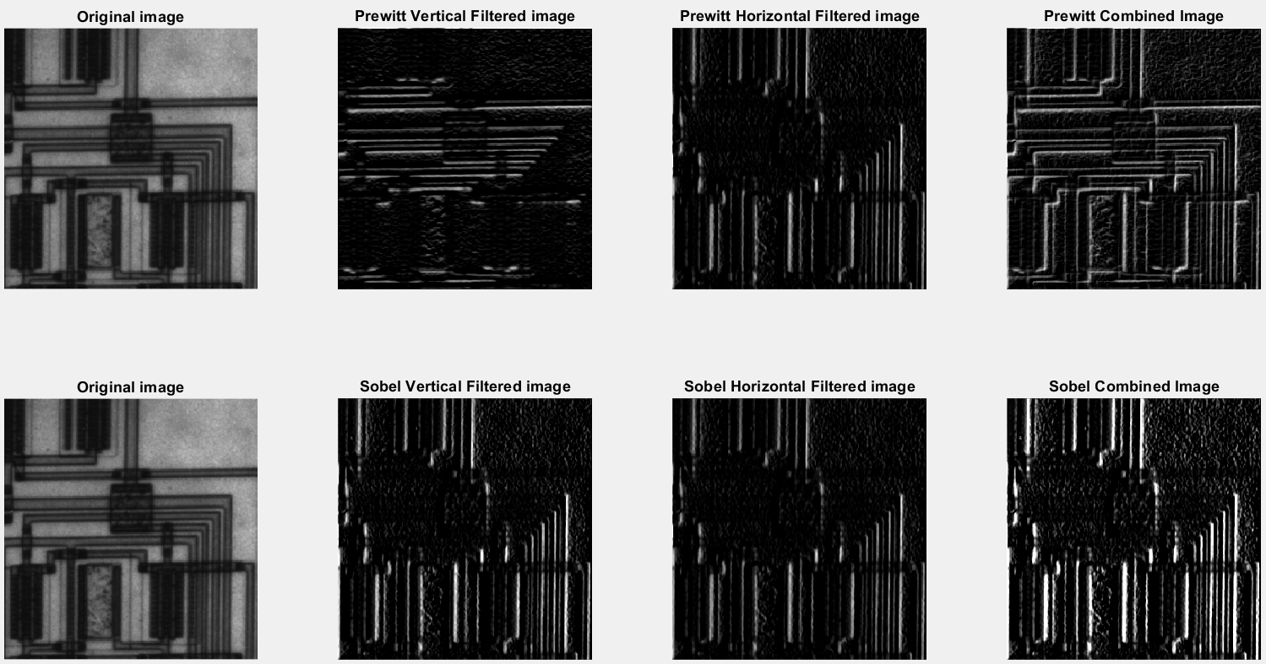

**APPLICATIONS:**

* In the case of audio electronics, Low pass filters are used to remove high frequencies from low frequency components.
* A low pass filter removes unwanted frequencies from interfering with the function of a bass speaker.
* A high pass filter will remove unwanted low frequencies from your tweeters.

**CONCLUSION:**

In this experiment, we learnt about Low pass filtering and High pass filtering. We then implemented Sobel and Prewitt filtering on images using MATLAB.

**NAME:** Junaid Altaf Girkar

**SAP ID:** 60004190057

**BATCH:** BE Comps A2